

**Lab Manual After Mids**

**COURSE NAME**

* Object Oriented Programming

**ASSIGNMENT**

* LAB MANUAL (15 Programs)

**SUBMITTED BY**

* Altahash Butt (12366) – Serial No : 1
* Farooq Ali (12391) –Serial No : 22

**SUBMITTED TO**

* Ma’am Sadaf Anwar

**SECTION**

* BSSE-2B (Morning)

**NATIONAL UNIVERSITY OF MODERN LANGUAGES**

Contents

1. LAB TASK: INTERFACES 4

CODE: 4

OUTPUT 4

2. LAB TASK : REGISTER FOR EXAMS 4

CODE: 4

OUTPUT: 7

3. LAB TASK : BASIC FRAME AND PANEL 7

CODE: 7

OUTPUT: 9

4. LAB TASK : GUI 9

CODE: 9

OUTPUT: 11

5. LAB TASK : FLOW LAYOUT 12

CODE: 12

OUtpUT: 13

6. LAB TASK: GRID LAYOUT 13

CODE: 13

OUtPUT: 14

7. LAB TASK : 4 Panels CNIC FORM 15

CODE: 15

OUTPUT: 19

8. LAB TASK : ACTION LISTENER 19

CODE: 19

OUTPUT: 21

9. LAB TASK : FRAME TO FRAME 22

CODE: 22

OUTPUT: 24

10. LAB TASK : ITEM LISTENER 25

CODE: 25

OUTPUT: 27

11. LAB TASK :BOLD, ITALIC FONT 27

CODE: 27

OUTPUT: 30

12. LAB TASK : JMENU BAR 30

CODE: 30

OUTpUT: 32

13. LAB TASK: EXCEPTION: 32

CODE: 32

OUTPUT: 34

14. LAB TASK : JSLIDER 35

CODE: 35

OUTPUT: 36

15. LAB TASK : DATABSE 37

CODE: 37

OUTPUT: 41

# LAB TASK: INTERFACES

## CODE:

package labinterface1;

interface MonthNumbers {

public static final int JANUARY = 1, FEBRUARY = 2, MARCH = 3, APRIL = 4,

MAY = 5, JUNE = 6, JULY = 7, AUGUST = 8, SEPTEMBER = 9, OCTOBER = 10, NOVEMBER = 11, DECEMBER = 12;

}

public class LabInterface1 implements MonthNumbers {

public static void main(String[] args) {

System.out.println("The number for January is " + JANUARY);

}

}

## OUTPUT

# LAB TASK : REGISTER FOR EXAMS

## CODE:

package labinterface2;

//Declare a Interface, RegisterForExams that contains single method register,

//implements the interface in two different classes (a) Student (b) Employee. Write down a

//Test Application that contains at least a function that takes Interface type Parameter

interface RegisterForExams {

public void register();

}

class student implements RegisterForExams {

String name;

int rollNo;

double Gpa;

student(String n, int r, double g) {

name = n;

rollNo = r;

Gpa = g;

}

@Override

public void register() {

System.out.println("Student Name : " + name);

System.out.println("Student Roll NO : " + rollNo);

System.out.println("Student GPA : " + Gpa);

}

}

class employee implements RegisterForExams {

String name;

int code;

int salary;

employee(String n, int c, int s) {

name = n;

code = c;

salary = s;

}

@Override

public void register() {

System.out.println("Employee Name : " + name);

System.out.println("Employee Code : " + code);

}

}

class interfaceTest {

void testApp(RegisterForExams a) {

a.register();

}

}

public class LabInterface2 {

public static void main(String[] args) {

interfaceTest t1 = new interfaceTest();

student s1 = new student("Farooq Ali", 12391, 3.5);

employee e1 = new employee("Farooq ", 6565, 10000);

t1.testApp(s1);

t1.testApp(e1);

}

}

## OUTPUT:

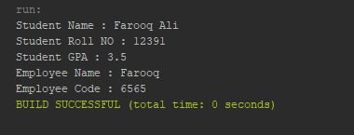

# LAB TASK : BASIC FRAME AND PANEL

## CODE:

package labtaskframesandpanels;

import java.awt.Color;

import javax.swing.JButton;

import javax.swing.JFrame;

import javax.swing.JLabel;

import javax.swing.JPanel;

public class LabTaskFramesAndPanels {

public static void main(String[] args) {

JFrame frame1 = new JFrame("");

frame1.setBounds(450, 200, 500, 500);

frame1.setBackground(Color.BLACK);

frame1.setDefaultCloseOperation(JFrame.EXIT_ON_CLOSE);

JLabel lbl1 = new JLabel("First Frame");

JLabel lbl2 = new JLabel("Second Frame");

JButton b1 = new JButton("OK");

JButton b2 = new JButton("OK");

JPanel p1 = new JPanel();

JPanel p2 = new JPanel();

p1.setBackground(Color.white);

p2.setBackground(Color.cyan);

JFrame frame2 = new JFrame("");

frame2.setBounds(0, 0, 400, 400);

frame2.setBackground(Color.BLACK);

frame2.setDefaultCloseOperation(JFrame.EXIT_ON_CLOSE);

p1.add(lbl1);

p1.add(b1);

p2.add(lbl2);

p2.add(b2);

frame1.add(p1);

frame2.add(p2);

frame1.setVisible(true);

frame2.setVisible(true);

}

}

## OUTPUT:

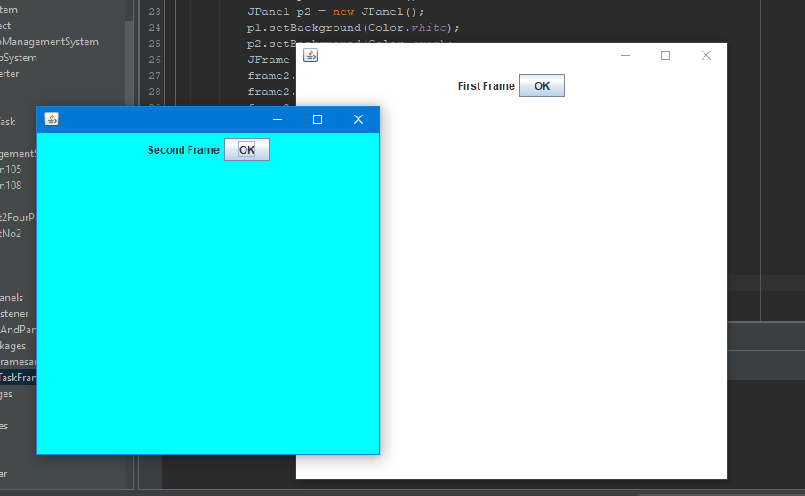

# LAB TASK : GUI

## CODE:

package labtaskgui;

import java.awt.Color;

import java.awt.Font;

import javax.swing.JButton;

import javax.swing.JComboBox;

import javax.swing.JFrame;

import javax.swing.JLabel;

import javax.swing.JPanel;

import javax.swing.JTextField;

public class LabTaskGui {

public static final Font MY_FONT = new Font(Font.DIALOG, Font.BOLD, 24);

public static void main(String[] args) {

JFrame frame = new JFrame();

frame.setDefaultCloseOperation(JFrame.EXIT_ON_CLOSE);

frame.setBounds(450, 200, 500, 500);

frame.setLayout(null);

JPanel panel1 = new JPanel();

JPanel panel2 = new JPanel();

panel1.setBackground(Color.darkGray);

panel2.setBackground(new Color(67, 107, 149));

panel1.setBounds(0, 0, 500, 250);

panel2.setBounds(0, 250, 500, 250);

JButton button = new JButton("OK");

button.setFont(MY_FONT);

JComboBox combo = new JComboBox();

combo.addItem("Male");

combo.addItem("Female");

combo.setFont(MY_FONT);

JLabel label = new JLabel("Enter Name Here");

label.setFont(MY_FONT);

JTextField textField = new JTextField("E.g: Farooq Ali");

textField.setFont(MY_FONT);

panel1.add(button);

panel1.add(combo);

panel2.add(label);

panel2.add(textField);

frame.add(panel1);

frame.add(panel2);

frame.setVisible(true);

}

}

## OUTPUT:

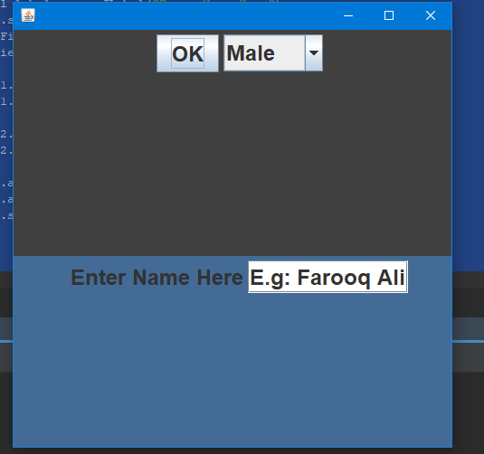

# LAB TASK : FLOW LAYOUT

## CODE:

package labtaskflowlayout;

import java.awt.Color;

import java.awt.FlowLayout;

import javax.swing.JButton;

import javax.swing.JFrame;

public class LabTaskFlowLayout {

public static void main(String[] args) {

JFrame frame1 = new JFrame("");

frame1.setBounds(450, 200, 400, 400);

frame1.setBackground(Color.BLACK);

frame1.setDefaultCloseOperation(JFrame.EXIT_ON_CLOSE);

frame1.setLayout(new FlowLayout(FlowLayout.CENTER,10,10));

JButton [] b = new JButton[10];

for(int i=0;i<10;i++){

b[i]= new JButton(String.valueOf(i));

frame1.add(b[i]);

}

frame1.setVisible(true);

}

}

## OUtpUT:

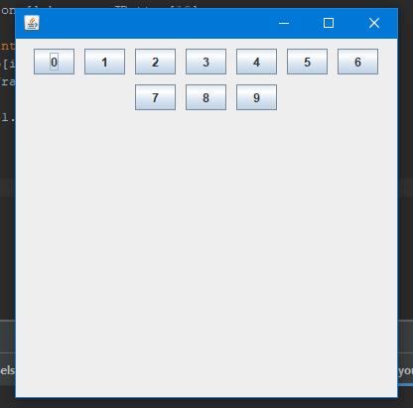

# LAB TASK: GRID LAYOUT

## CODE:

package labtaskgridlayout;

import java.awt.GridLayout;

import javax.swing.JButton;

import javax.swing.JFrame;

public class LabTaskGridLayout {

public static void main(String[] args) {

JFrame frame = new JFrame("Grid Layout");

frame.setDefaultCloseOperation(JFrame.EXIT_ON_CLOSE);

frame.setLayout(new GridLayout(3, 3, 10, 10));

frame.setBounds(450, 200, 450, 450);

JButton[] b = new JButton[10];

for (int i = 1; i < 10; i++) {

b[i] = new JButton(String.valueOf(i));

frame.add(b[i]);

}

frame.setVisible(true);

}

}

## OUtPUT:

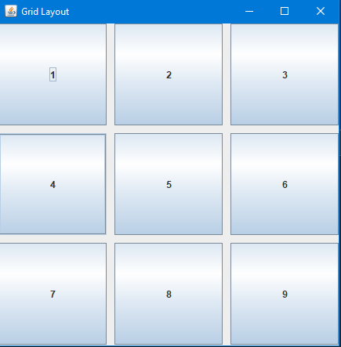

# LAB TASK : 4 Panels CNIC FORM

## CODE:

package labassignment2fourpanels;

import java.awt.BorderLayout;

import java.awt.Color;

import java.awt.Dimension;

import java.awt.Font;

import java.awt.Toolkit;

import javax.swing.JButton;

import javax.swing.JComboBox;

import javax.swing.JFrame;

import javax.swing.JLabel;

import javax.swing.JPanel;

import javax.swing.*;

import javax.swing.JTextField;

public class LabAssignment2FourPanels {

public static final Font MY_FONT = new Font("Times New Roman", Font.BOLD, 24);

public static void main(String[] args) {

Dimension screensize = Toolkit.getDefaultToolkit().getScreenSize();

JFrame frame = new JFrame();

frame.setDefaultCloseOperation(JFrame.EXIT_ON_CLOSE);

frame.setBounds(0, 0, screensize.width, screensize.height);

JPanel panel1 = new JPanel();

JPanel panel2 = new JPanel();

JPanel panel3 = new JPanel();

JPanel panel4 = new JPanel();

JButton button = new JButton("SUBMIT DETAILS");

String[] types = {"Male ", "Female", "Other"};

JComboBox combo = new JComboBox(types);

JLabel formTitle = new JLabel("ID CARD INFORMATION");

JLabel label1 = new JLabel("First Name");

JLabel label2 = new JLabel("Last Name");

JLabel label3 = new JLabel("Gender");

JLabel label4 = new JLabel("Date Of Birth");

JLabel label5 = new JLabel("All Rights Reserved. C(2020)");

JLabel img = new JLabel(new ImageIcon("C:\\Users\\faroo\\Desktop\\Farooq.png"));

JCheckBox terms = new JCheckBox("Agree to terms and policies.");

panel1.setBackground(Color.gray);

panel2.setBackground(Color.darkGray);

panel3.setBackground(new Color(115, 149, 153));

JTextField textField = new JTextField("e.g: Farooq ");

JTextField textField2 = new JTextField("e.g: Ali");

JTextField date = new JTextField("DD");

JTextField month = new JTextField("MM");

JTextField year = new JTextField("YY");

panel2.setLayout(null);

panel3.setLayout(null);

panel2.setPreferredSize(new Dimension(350, 0));

panel4.setPreferredSize(new Dimension(0, 70));

label5.setFont(MY_FONT);

formTitle.setFont(MY_FONT);

formTitle.setForeground(Color.white);

label1.setFont(MY_FONT);

label1.setForeground(Color.white);

label1.setBounds(15, 20, 250, 30);

img.setBounds(700, 0, 300, 330);

textField.setFont(MY_FONT);

textField.setBounds(15, 70, 250, 30);

label2.setFont(MY_FONT);

label2.setForeground(Color.white);

label2.setBounds(15, 120, 250, 30);

textField2.setFont(MY_FONT);

textField2.setBounds(15, 170, 250, 30);

label3.setFont(MY_FONT);

label3.setBounds(15, 20, 250, 30);

combo.setFont(MY_FONT);

combo.setBounds(15, 70, 250, 30);

combo.setFont(MY_FONT);

label4.setFont(MY_FONT);

label4.setBounds(15, 120, 250, 30);

date.setFont(MY_FONT);

date.setBounds(15, 170, 50, 30);

month.setFont(MY_FONT);

month.setBounds(70, 170, 50, 30);

year.setFont(MY_FONT);

year.setBounds(125, 170, 50, 30);

terms.setBounds(15, 220, 220, 30);

button.setBounds(15, 270, 250, 40);

button.setFont(MY_FONT);

panel1.add(formTitle);

panel2.add(label1);

panel2.add(textField);

panel2.add(label2);

panel2.add(textField2);

panel3.add(img);

panel3.add(label3);

panel3.add(combo);

panel3.add(label4);

panel3.add(date);

panel3.add(month);

panel3.add(year);

panel3.add(button);

panel3.add(terms);

panel4.add(label5);

frame.add(panel1, BorderLayout.NORTH);

frame.add(panel3, BorderLayout.CENTER);

frame.add(panel2, BorderLayout.WEST);

frame.add(panel4, BorderLayout.SOUTH);

frame.setVisible(true);

}

}

## OUTPUT:

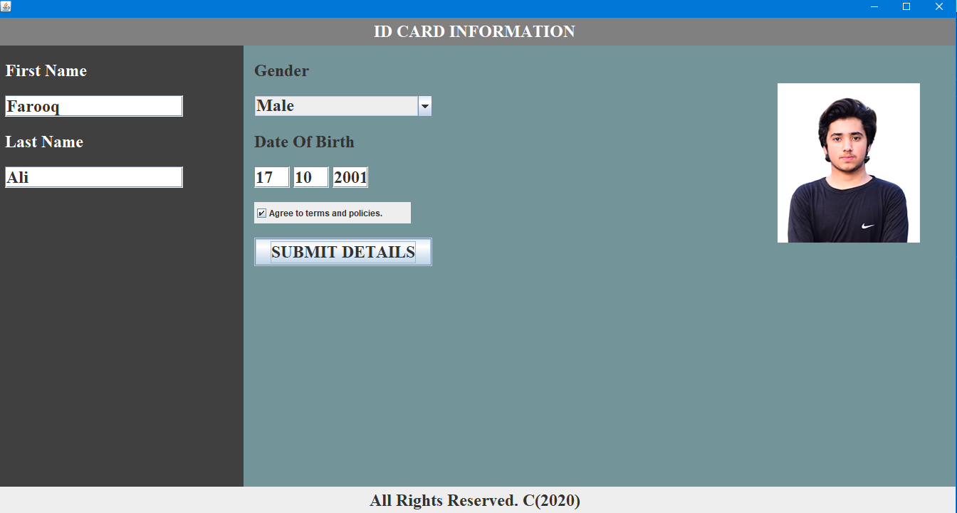

# LAB TASK : ACTION LISTENER

## CODE:

package actionlistenertask;

import java.awt.event.ActionEvent;

import java.awt.event.ActionListener;

import javax.swing.JButton;

import javax.swing.JFrame;

import javax.swing.JLabel;

import javax.swing.JTextField;

public class ActionListenerTask {

public static void main(String[] args) {

JFrame frame = new JFrame();

JButton button = new JButton("Ok");

JTextField tx = new JTextField("Enter Your Name");

JLabel label = new JLabel();

frame.setDefaultCloseOperation(JFrame.EXIT_ON_CLOSE);

frame.setBounds(500, 200, 420, 420);

frame.setLayout(null);

tx.setBounds(50, 100, 200, 30);

button.setBounds(120, 150, 100, 40);

label.setBounds(50, 200, 200, 30);

button.addActionListener(new ActionListener() {

@Override

public void actionPerformed(ActionEvent e) {

label.setText("Your Name is " + tx.getText());

}

});

frame.add(button);

frame.add(tx);

frame.add(label);

frame.setVisible(true);

}

}

## OUTPUT:

**BEFORE CLICKING OK**

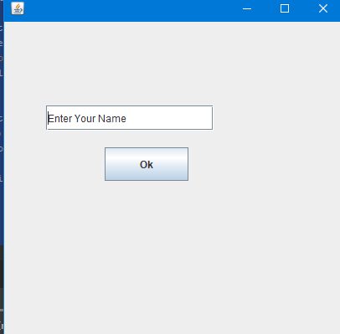

**AFTER CLICKING OK**

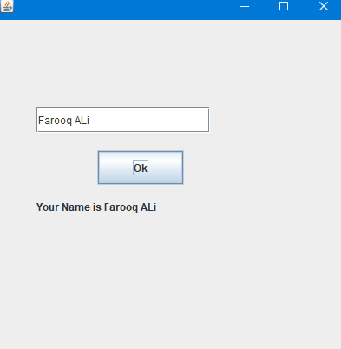

# LAB TASK : FRAME TO FRAME

## CODE:

package labtaskframetoframe;

import java.awt.Color;

import java.awt.event.ActionEvent;

import java.awt.event.ActionListener;

import javax.swing.JButton;

import javax.swing.JFrame;

import javax.swing.JLabel;

import javax.swing.JPanel;

public class LabTaskFrameToFrame {

public static void main(String[] args) {

JFrame frame1 = new JFrame("");

frame1.setBounds(450, 200, 500, 500);

frame1.setBackground(Color.BLACK);

frame1.setDefaultCloseOperation(JFrame.EXIT_ON_CLOSE);

JLabel lbl1 = new JLabel("First Frame");

JLabel lbl2 = new JLabel("Second Frame");

JButton b1 = new JButton("OK");

JButton b2 = new JButton("OK");

JPanel p1 = new JPanel();

JPanel p2 = new JPanel();

p1.setBackground(Color.white);

p2.setBackground(Color.cyan);

JFrame frame2 = new JFrame("");

frame2.setBounds(450, 200, 500, 500);

frame2.setBackground(Color.BLACK);

frame2.setDefaultCloseOperation(JFrame.EXIT_ON_CLOSE);

p1.add(lbl1);

p1.add(b1);

p2.add(lbl2);

p2.add(b2);

frame1.add(p1);

frame2.add(p2);

b1.addActionListener(new ActionListener() {

@Override

public void actionPerformed(ActionEvent e) {

frame1.dispose();

frame2.setVisible(true);

}

});

b2.addActionListener(new ActionListener() {

@Override

public void actionPerformed(ActionEvent e) {

frame2.dispose();

frame1.setVisible(true);

}

});

frame1.setVisible(true);

}

}

## OUTPUT:

**FIRST FRAME**

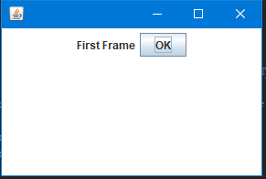

**AFTER CLICKING OK**

**SECOND FRAME**

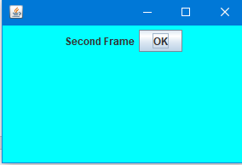

# LAB TASK : ITEM LISTENER

## CODE:

package labtaskit;

import java.awt.FlowLayout;

import java.awt.event.ItemEvent;

import java.awt.event.ItemListener;

import javax.swing.JCheckBox;

import javax.swing.JFrame;

import javax.swing.JLabel;

import javax.swing.JOptionPane;

public class mainITEM {

JFrame frame = new JFrame();

JLabel label1;

JCheckBox checkBox1 = new JCheckBox("MALE");

JCheckBox checkBox2 = new JCheckBox("FEMALE");

mainITEM() {

frame.setDefaultCloseOperation(JFrame.EXIT_ON_CLOSE);

frame.setBounds(450, 200, 420, 420);

frame.setLayout(new FlowLayout());

JLabel label1 = new JLabel("Enter Your Gender");

checkBox1.addItemListener(new ItemListener() {

public void itemStateChanged(ItemEvent e) {

if (checkBox1.isSelected()) {

JOptionPane.showMessageDialog(frame, "Male Selected");

checkBox1.setSelected(true);

}}

});

checkBox2.addItemListener(new ItemListener() {

@Override

public void itemStateChanged(ItemEvent e) {

if (checkBox2.isSelected()) {

JOptionPane.showMessageDialog(null, "Female Selected");

checkBox2.setSelected(true);

}

}

});

frame.add(label1);

frame.add(checkBox1);

frame.add(checkBox2);

frame.setVisible(true);

}

public static void main(String[] args) {

new mainITEM();

}

}

## OUTPUT:

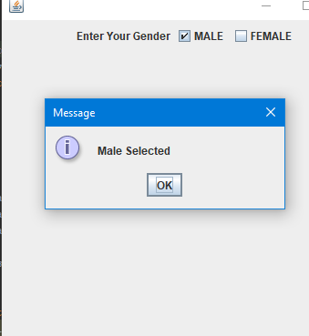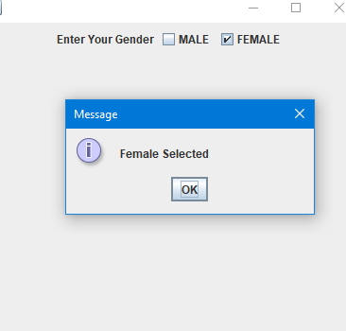

# LAB TASK :BOLD, ITALIC FONT

## CODE:

package fontbolditalictask;

import java.awt.Dimension;

import java.awt.FlowLayout;

import java.awt.Font;

import java.awt.event.ActionEvent;

import java.awt.event.ActionListener;

import javax.swing.JCheckBox;

import javax.swing.JFrame;

import javax.swing.JTextField;

public class FontBoldItalicTask{

public static final Font MY_FONT = new Font(Font.DIALOG, Font.PLAIN, 24);

public static void main(String[] args) {

JFrame frame = new JFrame();

frame.setDefaultCloseOperation(JFrame.EXIT_ON_CLOSE);

frame.setBounds(450, 200, 300, 250);

frame.setLayout(new FlowLayout());

frame.setResizable(false);

JTextField tx = new JTextField();

JCheckBox italic = new JCheckBox("Italic");

JCheckBox bold = new JCheckBox("Bold");

tx.setPreferredSize(new Dimension(250, 30));

tx.setFont(MY_FONT);

frame.add(tx);

frame.add(bold);

frame.add(italic);

italic.addActionListener(new ActionListener() {

@Override

public void actionPerformed(ActionEvent e) {

if(e.getSource()==italic){

if(italic.isSelected()){

tx.setFont(new Font(Font.DIALOG, Font.ITALIC, 24));

}

if(!italic.isSelected()){

tx.setFont(new Font(Font.DIALOG, Font.PLAIN, 24));

}

if(italic.isSelected() && bold.isSelected()){

tx.setFont(new Font(Font.DIALOG, Font.ITALIC + Font.BOLD, 24));

}

if(!italic.isSelected() && bold.isSelected()){

tx.setFont(new Font(Font.DIALOG,Font.BOLD, 24));

}

}

}

});

bold.addActionListener(new ActionListener() {

@Override

public void actionPerformed(ActionEvent e) {

if(e.getSource()==bold){

if(bold.isSelected()){

tx.setFont(new Font(Font.DIALOG, Font.BOLD, 24));

}

if(!bold.isSelected()){

tx.setFont(new Font(Font.DIALOG, Font.PLAIN, 24));

}

if(italic.isSelected() && bold.isSelected()){

tx.setFont(new Font(Font.DIALOG, Font.ITALIC + Font.BOLD, 24));

}

if(!bold.isSelected() && italic.isSelected()){

tx.setFont(new Font(Font.DIALOG,Font.ITALIC, 24));

}

}

}

});

frame.setVisible(true);

}

}

## OUTPUT:

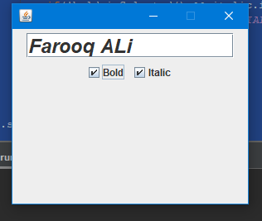

# LAB TASK : JMENU BAR

## CODE:

package labtaskmenubar;

import java.awt.Color;

import javax.swing.JFrame;

import javax.swing.JMenu;

import javax.swing.JMenuBar;

import javax.swing.JMenuItem;

public class LabTaskMenuBar {

public static void main(String[] args) {

JFrame f = new JFrame("JMENU BAR");

f.setBounds(400, 200, 500, 500);

f.setDefaultCloseOperation(JFrame.EXIT_ON_CLOSE);

f.setLayout(null);

JMenuBar menubar = new JMenuBar();

JMenu file = new JMenu("File");

JMenu edit = new JMenu("Edit");

JMenu view = new JMenu("View");

JMenuItem subFile = new JMenuItem("Open");

JMenuItem subEdit = new JMenuItem("New File");

JMenuItem subView = new JMenuItem("Save");

menubar.add(file);

menubar.add(edit);

menubar.add(view);

file.add(subFile);

edit.add(subEdit);

view.add(subView);

f.setJMenuBar(menubar);

f.setLayout(null);

f.setVisible(true);

}

}

## OUTpUT:

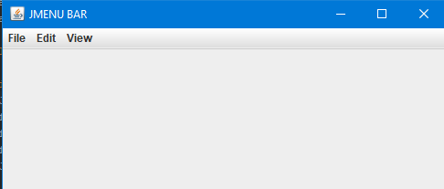

# LAB TASK: EXCEPTION:

## CODE:

package exceptionlab;

import java.util.Scanner;

public class ExceptionLab {

public static void main(String[] args) {

Scanner s = new Scanner(System.in);

int a,b,c;

System.out.println("enter a number");

a= s.nextInt();

System.out.println("Enter a number to divide by");

b=s.nextInt();

try{

c=a/b;

System.out.println(c);

}

catch(ArithmeticException e){

System.out.println("You cannot divide a number by 0");

}

String name = null;

System.out.println("Enter your name");

s.nextLine();

name= s.nextLine();

int [] arr = new int[5];

try{

if(name==""){

name = null;

}

System.out.println(name.length());

System.out.println("your name is "+name);

}

catch(NullPointerException e){

System.out.println(" Do not leave the field empty ");

}

try{

int convert= Integer.parseInt(name);

}

catch(NumberFormatException e){

System.out.println("You can not convert string into integer");

}

try{

arr[2]=100;

System.out.println("Array[2] is = "+arr[2]);

arr[6] = 200;

}

catch(ArrayIndexOutOfBoundsException e){

System.out.println("Enter valid array field");

}

}

}

## OUTPUT:

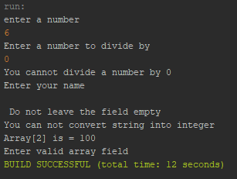

# LAB TASK : JSLIDER

## CODE:

package labtaskjslider;

import javax.swing.JFrame;

import javax.swing.JLabel;

import javax.swing.JPanel;

import javax.swing.JSlider;

import javax.swing.event.ChangeEvent;

public class LabTaskJslider {

public static void main(String[] args) {

JFrame frame = new JFrame();

int max = 100;

int min = 0;

int init = 50;

JPanel panel = new JPanel();

JSlider slider = new JSlider(JSlider.HORIZONTAL, min, max, init);

slider.setMajorTickSpacing(10);

slider.setMinorTickSpacing(1);

slider.setPaintTicks(true);

slider.setPaintLabels(true);

frame.setDefaultCloseOperation(JFrame.EXIT_ON_CLOSE);

frame.setBounds(450, 200, 300, 300);

panel.add(slider);

frame.add(panel);

frame.setVisible(true);

}

}

## OUTPUT:

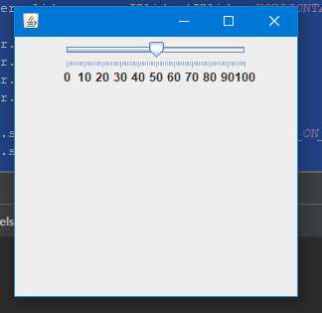

# LAB TASK : DATABSE

## CODE:

package loginfile;

import java.awt.CardLayout;

import java.awt.Color;

import java.awt.Cursor;

import java.awt.FlowLayout;

import java.sql.*;

import java.awt.Font;

import java.awt.event.ActionEvent;

import java.awt.event.ActionListener;

import java.awt.event.MouseAdapter;

import java.awt.event.MouseEvent;

import javax.swing.JButton;

import javax.swing.JFrame;

import javax.swing.JLabel;

import javax.swing.JOptionPane;

import javax.swing.JPanel;

import javax.swing.JPasswordField;

import javax.swing.JTextField;

import org.apache.commons.lang3.math.NumberUtils;

public class LoginFile {

JFrame frame = new JFrame();

JPanel panel1 = new JPanel();

JPanel titlePanel = new JPanel();

JLabel title = new JLabel("Admin Login");

JLabel label1 = new JLabel("Enter Your User Name");

JLabel label2 = new JLabel("Enter Your Password");

JLabel label3 = new JLabel("Forgot Password?");

JTextField userName = new JTextField();

JPasswordField password = new JPasswordField();

JButton login = new JButton("LOG IN");

public static final Font MY_FONT = new Font("Times New Roman", Font.BOLD, 20);

LoginFile() {

frame.setDefaultCloseOperation(JFrame.EXIT_ON_CLOSE);

frame.setLayout(null);

frame.setBounds(450, 200, 450, 450);

frame.setResizable(false);

//PANEL 1

panel1.setBackground(Color.darkGray);

panel1.setLayout(null);

panel1.setSize(450,450);

//TITLE PANEL

titlePanel.setLayout(new FlowLayout(FlowLayout.CENTER, 0, 11));

titlePanel.setBounds(0, 0, 450, 70);

titlePanel.setBackground(new Color(67, 107, 160));

//LABEL TITLE

title.setFont(new Font("Times New Roman", Font.BOLD, 36));

title.setForeground(Color.white);

//LABEL 1

label1.setBounds(120, 120, 200, 30);

label1.setForeground(Color.white);

label1.setFont(MY_FONT);

//LABEL 2

label2.setBounds(120, 210, 200, 30);

label2.setForeground(Color.white);

label2.setFont(MY_FONT);

//LABEL 3

label3.setBounds(145, 370, 250, 20);

label3.setForeground(Color.white);

label3.setFont(MY_FONT);

label3.setCursor(Cursor.getPredefinedCursor(Cursor.HAND_CURSOR));

//TEXTFIELD : USERNAME

userName.setBounds(120, 160, 200, 30);

//PASSWORD FIELD : PASSWORD

password.setBounds(120, 250, 200, 30);

//BUTTON : LOGIN

login.setBounds(160, 310, 120, 40);

login.setFont(MY_FONT);

login.setForeground(Color.black);

login.setBackground(new Color(200, 202, 204));

login.setFocusable(false);

//PANEL 1 ADD INTO

panel1.add(label1);

panel1.add(userName);

panel1.add(label2);

panel1.add(password);

panel1.add(login);

panel1.add(label3);

panel1.add(title);

titlePanel.add(title);

panel1.add(titlePanel);

login.addActionListener(new ActionListener() {

public void actionPerformed(ActionEvent e) {

Connection conn = null;

PreparedStatement pst = null;

ResultSet rs = null;

try {

Class.forName("net.ucanaccess.jdbc.UcanaccessDriver");

conn = DriverManager.getConnection("jdbc:ucanaccess://E:\\ProjectDatabase.accdb");

String query = "Select * from loginInfo where username='" + userName.getText() + "' and password='" + password.getText() + "'";

pst = conn.prepareStatement(query);

rs = pst.executeQuery();

if (rs.next()) {

JOptionPane.showMessageDialog(null, "Login Successfull");

} else {

JOptionPane.showMessageDialog(null, "Invalid username or password");

}

} catch (SQLException | ClassNotFoundException ex) {

JOptionPane.showMessageDialog(null, "Exception Error");

System.out.println(ex.getMessage());

}

}

});

frame.add(panel1);

System.out.println("Hello");

frame.setVisible(true);

}

public static void main(String[] args) {

new LoginFile();

}

}

## OUTPUT:

